

Nationally Determined Contribution of Bangladesh

Implementation roadmap  
___________________________________________________

Table of contents

1 Introduction 1

1.1 Integration of NDC implementation and NAP Implementation 2

2 NDC implementation in Bangladesh 3

2.1 The climate change policy landscape in Bangladesh 3

2.2 The wider policy landscape in Bangladesh 3

3 Governance and coordination 5

3.1 Institutional arrangements for NDC implementation 5

3.1.1 NDC-NAP Advisory Committee 6

3.1.2 NDC-NAP coordination Committee 7

3.1.3 NDC and NAP implementation analytical support 8

3.1.4 NDC sectoral working groups 8

3.1.5 NAP Sectoral Working Groups 9

3.2 Stakeholder engagement 9

3.3 Building institutional capacity 10

3.4 NDC implementation activities: Governance 10

4 Mitigation 12

4.1 Overview of mitigation policy 12

4.2 NDC updating 12

4.3 Delivery of GHG reductions 12

4.4 Next steps on mitigation 13

4.5 Capacity building for mitigation 13

4.5.1 Analytical capacity: 13

4.5.2 Policy capacity 14

4.5.3 Technical capacity 14

5 Adaptation 15

5.1 The overall NAP process 17

5.2 Major sectoral impacts, vulnerability and adaptation to climate change 18

5.2.1 Agriculture and food security 18

5.2.2 Water security in Bangladesh 18

5.2.3 Health 19

5.2.4 Fisheries 19

5.2.5 Livestock 20

5.2.6 Livelihood 20

5.2.7 Forest, biodiversity and ecosystems 20

5.3 Adaptation actions past and present 21

5.3.1 Potential adaptation actions 22

5.3.2 Cost of adaptation 22

6 Resourcing the plan 24

6.1 The climate finance landscape in Bangladesh 24

6.2 Oversight and coordination 26

6.3 Developing more accurate costings for the NDC 26

6.4 Assessing funding options 26

6.4.1 International bilateral and multilateral funding sources 26

6.4.2 Nationally Appropriate Mitigation Actions 27

6.4.3 Climate-proofing of existing national budgets 27

6.4.4 New international funding arrangements 27

6.4.5 Further engagement with the private sector 28

6.5 Measurement, reporting and verification (MRV) of climate finance 28

6.6 NDC implementation activities: finance 28

7 Measurement, reporting and verification (MRV) 30

7.1 The GHG inventory 30

7.2 GHG projections 30

7.3 Measurement and evaluation of individual measures 31

7.4 Governance for MRV 31

7.5 The MRV system 32

7.6 NDC implementation activities: MRV 34

**Appendices**

Appendix 1: summary of activities for implementing the NDC

Appendix 2: adaptation options for different sectors in Bangladesh

# Introduction

Bangladesh is one of the most vulnerable countries in the world to the effects of climate change, which poses a significant risk to the economic development of the country. According to the [Climate Change Vulnerability Index](https://maplecroft.com/portfolio/new-analysis/2014/10/29/climate-change-and-lack-food-security-multiply-risks-conflict-and-civil-unrest-32-countries-maplecroft/) of 2015, Bangladesh’s economy is more at risk to climate change than any other country. With a per capita gross domestic product, or GDP, of about $1,220, the economic losses due to climate change in Bangladesh over the past 40 years were at an estimated $12 billion, depressing GDP annually by 0.5 to 1 percent.

Consequently, Bangladesh is adopting a two-fold strategy against climate change impacts. The main focus of Bangladesh’s activities is on increasing resilience to the impacts of climate change. At the same time, the country is also working to achieve lower greenhouse gas (GHG) emissions as well as more resilient development. The Government of Bangladesh prepared the Bangladesh Climate Change Strategy and Action Plan[1] (BCCSAP) for adaptation and Low Carbon Development (LCD), which is an overarching document on climate change and is now being updated. The Seventh Five Year Plan[2] included green growth and within this, it articulated three themes, one of which is climate change management and resilience.

With this in mind, Bangladesh has prepared this Implementation Roadmap for the Nationally Determined Contribution (NDC) to manage growing emissions without compromising the required development and to allow Bangladesh to play its role in global efforts to limit temperature rise to two degrees or preferably 1.5 degrees above pre-industrial levels.

Countries’ Nationally Determined Contributions (NDCs) are central to the Paris Agreement that was reached in December 2015. They set out each country’s approach to becoming a low carbon and climate resilient economy, as well as how this will be coordinated, managed, tracked and financed. Countries submitted their intended NDCs (known as INDCs) in advance of the Paris Climate Conference. Bangladesh submitted its INDC to the United Nations Framework Convention on Climate Change (UNFCCC) in September 2015. Countries are now encouraged to ratify the Paris Agreement and to implement their NDCs. Bangladesh ratified the Paris Agreement on 21 September 2016 and its NDC can now be found on the UNFCCC’s interim NDC Registry[3].

As a country that has an NDC with a timeframe to 2030, Bangladesh is requested under the Paris Agreement to submit an updated NDC by 2020. There then follows a regular process of updating NDCs every five years after that, with regular global ‘stocktakes’ to assess globally the extent to which progress is being made to the overall aims of the Paris Agreement.

Bangladesh’s NDC describes its plans for tackling greenhouse gas (GHG) emissions and adapting to unavoidable climate change. This recognises two important factors:

* On the one hand, as a climate vulnerable country, adaptation remains the priority for Bangladesh. Bangladesh’s NDC therefore has an adaptation component that describes what Bangladesh has already done on adaptation and what the priorities are going forward.
* On the other hand, Bangladesh is committed to taking a progressive approach to developing its economy on a low carbon pathway. In the NDC, Bangladesh committed to reduce GHG emissions in the power, industry and transport sectors by 5% below ‘business-as-usual’ GHG emissions by 2030 using only domestic resources, or by 15% below ‘business-as-usual’ GHG emissions by 2030 if sufficient and appropriate support is received from developed countries.

The focus under the Paris Agreement now shifts to implementation. It is important to note that the Paris Agreement states that the ‘least developed countries *may* prepare and communicate strategies, plans and actions for low greenhouse gas emissions development reflecting their special circumstances’. As a progressive member of the UNFCCC, Bangladesh was one of the first countries following the Paris Agreement to put in place a process for developing plans for NDC implementation. Bangladesh reserves the right to change its position on implementation of its NDC in future.

Implementation of Bangladesh’s NDC will involve multiple stakeholders and will be taken forward through a number of different workstreams and programmes. The whole process will be set within the strategic framework of the Bangladesh Climate Change Strategy and Action Plan, which, as mentioned above, is currently under review. This document – Bangladesh’s NDC Implementation Roadmap – describes and guides the overarching NDC implementation process and covers cross-cutting NDC implementation issues, so as to ensure that NDC implementation is taken forward in a holistic, joined-up and effective manner.

Beneath this, NDC implementation will be driven by a number of different documents and processes. The primary vehicle for taking forward adaptation policy and implementation will be the National Adaptation Plan (NAP) process, which will implement the adaptation element of the NDC.

NDC Sectoral Action Plans have also been produced for the power, industry and transport sectors. These action plans describe the actions that will be taken in each of these three sectors to deliver the GHG emissions reductions required to meet the overall NDC GHG reduction targets. They also consider how the power, industry and transport sectors will be most impacted by climate change and what actions can be taken by these sectors to strengthen their climate resilience.

The NDC implementation roadmap covers the time period 2016-2025, with a particular focus on the period up to 2020. The reason for this focus on the near term time horizon is that the roadmap, and the accompanying sectoral action plans, set out the detailed actions required to implement the NDC and as such it is logical to focus most on the next few years. These detailed actions are summarised at the end of each section, as well as being listed in full in Appendix 1. Detailed actions on mitigation and adaptation can be found in the respective NDC implementation sectoral action plans.

It is expected that this will be a ‘live’ document and may be updated over time, not least when the NDC gets updated according to the timeline mentioned above. It might also be added to over time, for example if new sectors are added to the quantified mitigation contribution in the NDC, in line with any future updates to the NDC.

## Integration of NDC implementation and NAP Implementation

The UNFCC established the national adaptation plan (NAP) process as a way to facilitate adaptation planning in least developed countries (LDCs) and other developing countries[4]. As the NAP process in Bangladesh has yet to start in full, Bangladesh is keen to integrate these two separate processes (NDC and NAP) to attain synergies in the actual implementation phase. Based on future updating of the NDC, the NDC implementation road-map could potentially be extended to cover other sectors that are relevant to adaptation as well. Once the NAP process is fully underway, there will be an integrated arrangement for the implementation of both the NDC and the NAP.

# NDC implementation in Bangladesh

The implementation of Bangladesh’s NDC builds on and supports existing action that the Government of Bangladesh is taking on climate change, as well as on other key non-climate related strategies and plans. Before considering NDC implementation in more depth, it is helpful to first consider how NDC implementation fits with wider government policy. Indeed, it is helpful not to think of NDC implementation as a wholly climate change-focused and separate process, but instead as a vital component of delivering sustainable and low carbon growth in Bangladesh and meeting a wider raft of objectives and priorities, including energy access, economic growth, productivity, poverty reduction and improved quality of life. In this sense they link closely to the UN’s Sustainable Development Goals[5].

## The climate change policy landscape in Bangladesh

The main strategic direction on climate change policy in Bangladesh is set by the Bangladesh Climate Change Strategy and Action Plan (BCCSAP). This was published in 2009 and is built on six pillars:

* Food security, social protection and health
* Comprehensive disaster management
* Infrastructure
* Research and knowledge management
* Mitigation and low carbon development
* Capacity building and institutional strengthening

The BCCSAP is very much Bangladesh’s overarching strategy on climate change and sets the strategic direction for climate policy. The BCCSAP is currently being reviewed and updated, and the new version is due to be published in 2018. The Government will be consulting on the update of the BCCSAP throughout 2017, and will take decisions on the scope and content of the updated plan accordingly, based on stakeholder feedback. But it is likely that the updated plan will continue to be a strategic and high-level document, setting out the overarching approach to climate change in Bangladesh.

The NDC can be seen as a high-level communication to the international community of Bangladesh’s overall approach to climate change action, on both mitigation and adaptation. The NDC is, in turn, being implemented on the ground through this NDC Implementation Roadmap and the Sectoral Action Plans that sit beneath it, and for adaptation through the National Adaptation Plan (NAP) process (see Section 5.1 for more details).

## The wider policy landscape in Bangladesh

It is important to note that the NDC is not just a climate change document. It charts a course to sustainable, low carbon and climate resilient growth and as such should play a key role in Bangladesh’s development. As outlined in the individual NDC sectoral action plans, there are many ways in which action to implement the NDC can support Bangladesh’s development agenda.

* Expansion of renewable energy can help shield the country from costs of importing energy, as well as being a cost effective, pragmatic solution for providing electricity to off-grid areas, which is a significant challenge in Bangladesh.
* Improving industrial energy efficiency can help increase productivity and allow ‘carbon space’ for domestic industry to grow to meet increasing domestic and international demand.
* Modernising transport infrastructure is vital for economic growth, whilst tackling congestion removes a key barrier to growth.

This NDC Implementation Roadmap and the accompanying Sectoral Action Plans will play a key role in driving forward action in the key sectors of the NDC. But ultimately, the aim is to mainstream climate change so that it underpins everything that the Government and other stakeholders do in Bangladesh. Achieving outcomes such as those outlined above will be easier if climate change is deeply embedded in the Five Year Planning process that is central to development in Bangladesh. The NDC therefore aligns closely with the Seventh Five Year Plan (7FYP), which proposes a number of key activities to facilitate climate change mitigation and adaptation, including enhancing understanding on low carbon development, promoting a whole-government approach to climate readiness, improving capacity, improving coordination and communication amongst key institutions and encouraging innovation and research. All of these will aid and support NDC implementation. As part of the implementation of the 7FYP, the Government is developing sectoral action plans for the thirteen sectors set out in the 7FYP[6]. The Ministry of Environment and Forests, who will coordinate action on NDC implementation (see section 3 on Governance and coordination), will work closely with the Planning Commission, who coordinate action on the 7FYP to ensure that climate considerations are integrated throughout the relevant 7FYP action plans, such as transport and communication, agriculture, power and energy and industrial and economic services. Furthermore, the 7FYP action plan for the Environment and Climate Change sector will be aligned closely with the BCCSAP and the NDC, as well as highlighting the strong links between climate change and other environmental parameters.

Table 1: links between the 7FYP and climate policy

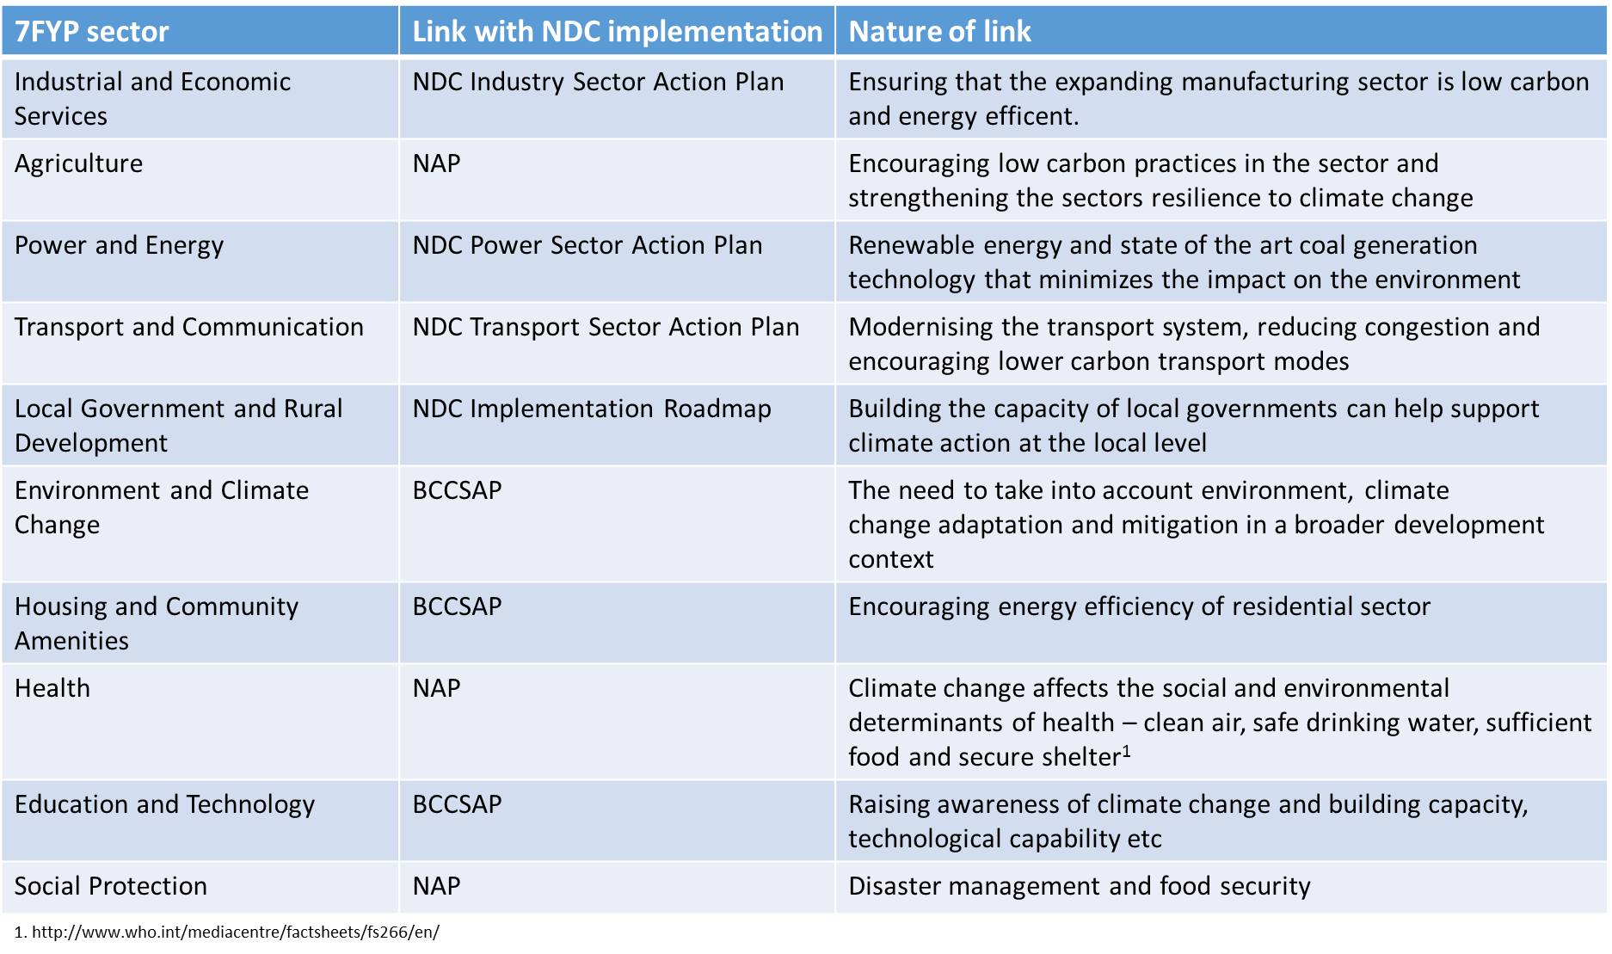

# Governance and coordination

## Institutional arrangements for NDC implementation

Key to successful NDC implementation is good governance and coordination, between sectors, between different stakeholders and between different levels of government and civil society, so that activities at the local level are appropriately aligned with policy, all the way up to the NDC, the BCCSAP and the Five Year Plans. Effective governance can lead to greater effectiveness and efficiency (as activities are properly aligned and synergised), consistency (as consistent approaches and methodologies are adopted) and completeness (with the overall coordinating body ensuring activity is appropriately targeted across different sectors).

This section explains the proposed governance arrangements for overall coordination of NDC implementation, as outlined in Figure 1. Arrangements for governance and coordination at the sectoral level can be found in each of the NDC Sectoral Action Plans. NAP Integration is also shown in the diagram for better synergy and attaining adaptation-mitigation co-benefits.

Figure 1: Governance arrangements for NDC-NAP implementation framework

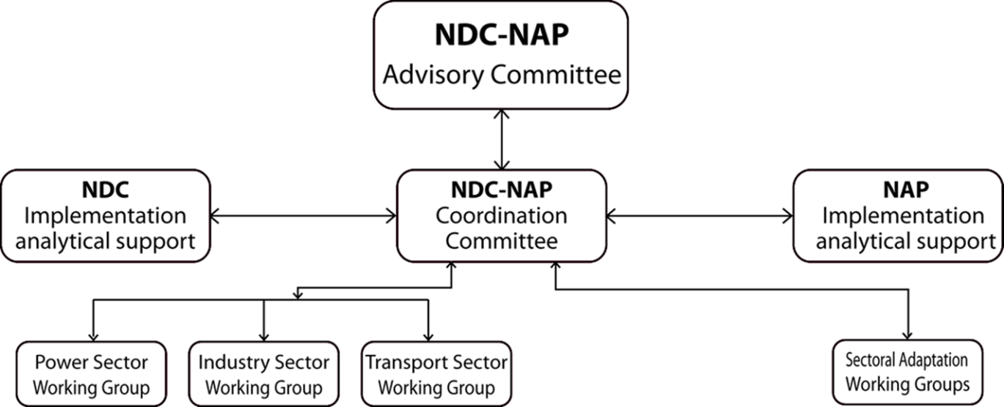

The arrangements proposed above are specifically proposed for the implementation of the NDC with an aim to include and integrate NAP implementation side by side under one single framework. Depending on the outcome of the review of the BCCSAP, such arrangements might be expanded to also cover the updated BCCSAP, as doing so will be more efficient than setting up parallel arrangements for the management and implementation of the BCCSAP. If this was done, then it might be expected that further sectoral working groups for both mitigation and adaptation would be set up to manage policy development and tracking of progress in those sectors. See the section below on ‘NDC Sectoral Working Groups’ for more details.

Furthermore, the arrangements above envisage a number of adaptation working groups (more to be included from the NAP) that would feed in to the discussions and work of the NDC sectoral working groups as needed on specific adaptation-related issues. The proposed Adaptation Working Groups are put forward without prejudice to any institutional arrangements that would be set up to develop and implement the forthcoming NAP.

Both the processes (NDC and NAP) can have a single Advisory Committee headed by the MoEF Secretary, and a single Coordination Committee headed by the Additional Secretary from MoEF, backed by separate implementation analytical support for the smooth functioning of these committees. A separate secretariat also needs to be established to look after the day to day functions of the NDC and NAP implementation activities. The detail on the proposed adaptation working groups may have to be separately assessed in the NAP and then integrated into the single proposed framework.

Not all of the arrangements set out in Figure 1 would be entirely new, but this new institutional structure would formalise the arrangements and clarify roles and responsibilities. An NDC Advisory Committee was set up temporarily for the duration of the INDC and NDC implementation projects and this committee can be continued as the proposed permanent NDC-NAP Advisory Committee. An NDC Technical Committee was also set up for the duration of these projects and this could form the basis for the proposed NDC-NAP Coordination Committee.

### NDC-NAP Advisory Committee

The NDC-NAP Advisory Committee will be chaired by the Secretary, MoEF, and will be the most senior decision-making body on NDC and NAP Implementation. Senior representatives from the organisations listed below will be the members of the Committee and will give final sign-off for proposed policies to be introduced, progress reports and other NDC and NAP Implementation reports, before they are published and/or sent to their respective domestic or international audiences. The Committee will give strategic advice on cross-cutting issues regarding NDC implementation and will also regularly review progress on overall NDC implementation. The Advisory Committee may include new members as and when necessary.

The Committee will consist of senior representatives from:

* Ministry of Environment and Forests (MoEF) - Chair
* Sectoral focal point ministries
  + Power Division
  + Ministry of Industry
  + Road Transport and Highway Division (RTHD)
* Other relevant sectoral ministries
  + Ministry of Railways
  + Ministry of Shipping
  + Ministry of Civil Aviation and Tourism
  + Ministry of Agriculture
  + Ministry of Water Resources
  + Ministry of Disaster Management and Relief
  + Planning Commission (General Economics Division)
  + Ministry of Finance
  + Prime Minister’s Office
  + Ministry of Women and Children Affairs
  + Ministry of Foreign Affairs
  + Ministry of Land
  + Ministry of Fisheries & Livestock
  + Ministry of Health and Family Welfare
  + Ministry of Local Government, Rural Development and Co-Operatives

The Committee’s functions are as follows:

* Overall responsibility for NDC and the NAP implementation.
* Advise and provide overall guidance to the NDC-NAP Coordination Committee and approve the decisions of the Coordination Committee.
* Regularly review the progress and provide necessary directions for attaining the targets.
* Provide strategic advice on cross-cutting issues regarding NDC-NAP implementation.

### NDC-NAP coordination Committee

The NDC-NAP Coordination Committee will be the main focal point for the UNFCCC and will also act as the secretariat to the NDC Advisory Committee. It will be based within the Ministry of Environment and Forests (MoEF), as part of its lead role in the Government of Bangladesh on climate change and liaising with the UNFCCC.

They will prepare materials for the Advisory Committee, and seek sign off and approval from the Advisory Committee as necessary, for example for an NDC monitoring report. The Committee may include new members as and when necessary.

A full list of its functions is as follows:

* Responsibility for the Paris Agreement (PA) within Bangladesh, reviewing the PA for key milestones and requirements, and ensuring that action is taken within the Government to respond to these. For example, responsible for coordinating the regular update of NDCs, contribution to the Global Stocktake etc.
* Reporting to the UNFCCC on NDC and NAP issues through the Advisory Committee.
* Liaison with NDC Sectoral Working Groups.
* Managing of analytical support on NDC and NAP implementation (e.g. constituting the appropriate group(s), developing terms of reference for the analytical work and considering the need for external analytical work (e.g. consultancy projects) where limited capacity exists within government).
* Commissioning technical assistance projects on NDC and NAP implementation as required.
* Coordination of overall stakeholder engagement on NDC and NAP implementation, for example convening regular (e.g. annual) stakeholder forums on NDC implementation, to review progress and seek stakeholder inputs on future decisions. See Section 3.2 below for more details. Note that NDC Implementation Sectoral Focal points will be responsible for stakeholder engagement on sector issues (e.g. Ministry of Industry would be responsible for convening a stakeholder workshop on NDC implementation in the industry sector).
* Making recommendations to the Advisory Committee on cross-cutting issues.
* Making recommendations to the Advisory Committee on new policies.
* Discussions on cross-sectoral issues, e.g. capacity building needs, MRV, before they go to the Advisory Committee for sign-off.
* Review of progress reports before sign-off by Advisory Committee.

The same organisations as the Advisory Committee will be represented on the Coordination Committee but at a more working level.

### NDC and NAP implementation analytical support

It will be important to have access to robust analysis, both for decisions to be taken on NDC and NAP implementation and for good quality and effective MRV (see section 7). Rather than being a formal committee, it is suggested that a pool of analytical resource is drawn up across a number of Ministries. This pool could provide regular and ad-hoc support for analysis and data, both to the NDC-NAP Coordination Committee and to Sectoral Working Groups. It is suggested that this pool of analysts is managed by the Department of Environment (DoE), which is the technical arm of the MoEF. In this role, the DoE will liaise with different ministries to request analytical support and to agree terms of reference (e.g. their role, the regularity of input needed, the type of analytical support required etc).

An indicative list of tasks for the NDC and NAP analytical support team could be as follows:

* Agreement on consistent methodologies for analysing mitigation potential (e.g. common discount rates, common assumptions on technological uptake rates etc).
* Agreement on common parameters for MRV, e.g. population data, GDP data etc.
* Ex-ante and ex-post reports on GHG savings from policies and measures.
* Peer review of analysis carried out by others in the analytical pool.
* Collection of data, both domestic data and international benchmarks that could be used in the absence of robust domestic data.
* Review of international reports that might provide relevant information.
* Feedback to NDC-NAP Coordination Committee on areas for improvement in the evidence base (e.g. suggestions for technical assistance projects that could help improve the robustness of data in a given area).

As explained above, the DoE will manage the analytical support and put requests for analysis to the appropriate analysts. They will also coordinate strategic priorities on data, liaising with the NDC-NAP Coordination Committee in MoEF and the analysts, to identify which areas need further development and ensuring that appropriate resources and capacity building is being targeted at these areas.

### NDC sectoral working groups

Three NDC sectoral working groups are proposed, covering power, transport and industry, the three sectors with quantified GHG reduction commitments in the NDC. More information on these groups, their membership and functions, can be found in the NDC Sectoral Action Plans for the respective sectors. These working groups will liaise closely with any institutional structures or processes already set up in relation to that sector, for example any such groups or committees for the 7FYP.

As outlined above, should the proposed governance arrangements outlined in this chapter be expanded in future to cover the BCCSAP more generally, then one would expect more sectoral working groups to be added as appropriate. Even if not, more groups might be added in future if the scope of the mitigation contribution in the NDC is expanded to include other sectors.

As the NDC covers adaptation, then it is expected that the sectoral working groups will need some technical input on adaptation and climate resilience-related issues. For example, the NDC Industry Sector Action Plan looks at ways in which the industry sector might be impacted by climate change and what the sector can do to strengthen its resilience and reduce its vulnerability to climate change. However, there is little adaptation-related expertise either within the NDC focal point for industry (Ministry of Industries) or within the members of the NDC Industry Working Group. It is therefore likely that the Industry Working Group will call on the Adaptation Working Group to provide support and possibly even to carry out studies on behalf of the Industry Working Group to help it develop adaptation policy for the industry sector.

Whether or not the NDC Adaptation Working Group has a remit over adaptation-related issues in other sectors, such as forestry and agriculture, will also depend on what is decided for the NAP institutional arrangements, and on whether these NAP arrangements provide the adaptation input required for NDC implementation, or whether an NDC Adaptation Working Group is set up in parallel to the NAP arrangements. Hence at this moment it is not possible to clearly define the membership of this group. Generally speaking, it would consist of (a) general adaptation experts, (b) experts on adaptation issues in the power, industry and transport sectors and possibly (c) experts on adaptation in other sectors such as forestry and agriculture.

### NAP Sectoral Working Groups

At the time of writing this NDC Implementation Roadmap, it is not known what institutional arrangements will be set up for the NAP process. But it is expected that similar arrangement should be suggested for better coordination and implementation. It may not make sense to have an NDC Adaptation Working Group if it duplicates the institutional structures and procedures that will be set up for the NAP process in due course. In future, it might be that a slightly different group (one set up as part of the NAP process) provides the kind of support on adaptation-related NDC issues mentioned above.

## Stakeholder engagement

Stakeholder engagement will be important throughout the NDC implementation process. It is necessary to get broad buy-in for NDC implementation and the actions that it will entail, but also to help shape the process, by taking advantage of the creativity and technical expertise on offer from a range of stakeholders.

Stakeholder engagement on NDC implementation will be coordinated by the NDC Coordination Committee, with Sectoral Focal Points coordinating specific sector-focused stakeholder engagement. Stakeholder engagement can take on many forms with different objectives, as seen below.

Table 2: Key objectives of stakeholder engagement for the implementation of NDC

|  |  |
| --- | --- |
| Stakeholder engagement | Objective |
| Sharing information on the Paris Agreement and on NDC implementation | To broaden buy-in and public support for climate action and for NDC implementation, and to build knowledge capital in key institutions. |
| Consultations on specific interventions and policies | To seek technical expertise to help shape and improve draft policies. |
| Sharing of experience and lessons learned with international partners | To increase awareness and appreciation of action carried out in Bangladesh and to transfer knowledge and best practice (in both directions – others learning from Bangladesh and Bangladesh learning from others). |
| Sharing of NDC implementation progress reports | Improve understanding of progress made and or areas where further work is needed, increase buy-in for action in new areas or increasing efforts in existing areas. |

Stakeholder workshops were convened in 2015, to socialise the INDC, and also in 2016 and 2017 to feed in stakeholder views to the development of this roadmap and the accompanying Sectoral Action Plans. It is proposed that a further NDC implementation stakeholder workshop is organised in the second half of 2017 to present the NDC implementation roadmap to a wider range of stakeholders and to raise their awareness of and buy-in for the NDC implementation process.

## Building institutional capacity

A range of capacities and skills will be needed to ensure effective governance and coordination of the NDC implementation process. A good deal of capacity already exists in the central NDC Coordination Team in MoEF and DoE, and they will play a key role in identifying capacity needs in other Ministries and supporting them to build the capacity (e.g. through discrete technical assistance projects). There may also be a need for specific capacity building within MoEF and DoE to help it fulfil its coordination function on NDC implementation as effectively and efficiently as possible. This could include:

* Expertise in bankable project development and management especially for the Green Climate Find (GCF), the Global Environment Facility (GEF) and other bi-lateral and multilateral agencies.
* Capacity building on Monitoring, Reporting and Verification (MRV), including capacity development in GHG emissions assessment in different sectors including data generation system and management.
* Capacity development in climate change negotiations to strengthen the Government positions within the international negotiations.
* Expertise in using appropriate tools for project management, for example Gantt charts, critical path tools and risk registers.
* Expertise in and understanding of good governance structures and processes, for example well-managed committees and working groups. For example, useful lessons can be learned from other countries that have previously set up such institutional structures.
* Understanding of wider government policy, for example economic and development plans, and sectoral master plans.

More widely across the Government, other capacities that may need further development include:

* Experience and expertise in reporting policy implementation to senior officials and ministers.
* Capacity-building on gender mainstreaming for implementing ministries, departments and agencies.
* Basic knowledge of climate policy across key ministries, in particular an understanding of how their core work areas link with the climate agenda and the UN’s Sustainable Development Goals.

## NDC implementation activities: Governance

|  |  |  |  |
| --- | --- | --- | --- |
| *Activity* | *Responsibility* | *Timeline* | *Indicative cost / resource needs* |
| ***Governance*** | | | |
| *Draft detailed terms of reference for the NDC Implementation Advisory and Technical Committees* | *DoE* | *September 2017* | *Minimal* |
| *Write to proposed members of NDC Implementation Advisory and Technical Committees, inviting them to join* | *DoE* | *November 2017* | *Minimal* |
| *Draft detailed terms of reference for the NDC implementation analytical support* | *DoE* | *November 2017* | *Minimal* |
| *Arrange NDC Implementation stakeholder engagement workshop, to socialise the roadmap and NDC implementation more widely* | *DoE* | *Autumn 2017* | *Est 250,000 BDT* |
| ***Capacity building*** | | | |
| *Develop system of electronic data archiving for mitigation-related data* | *DoE* | *June 2018* | *TBD* |
| *Seek international support for comprehensive data review of mitigation data in power, industry and transport* | *MoEF* | *Autumn 2017* | *Minimal? Some staff time.* |
| *Draft terms of reference for comprehensive data review* | *DoE* | *October 2017* | *Minimal? Some staff time.* |
| *Launch tender for comprehensive data review* | *DoE* | *December 2017* | *Minimal? Some staff time.* |
| *Seek international support for capacity building on mitigation modelling* | *MoEF* | *Autumn 2017* | *Minimal? Some staff time.* |
| *Draft terms of reference for capacity building on mitigation modelling* | *DoE* | *October 2017* | *Minimal? Some staff time.* |
| *Launch tender for capacity building on mitigation modelling* | *DoE* | *December 2017* | *Minimal? Some staff time.* |
| *Consider options for international sharing of best practice on policy design* | *MoEF* | *June 2018* | *TBD* |
| *Write report on possible impact assessment approach for GoB* | *MoEF* | *December 2018* | *TBD* |
| ***NDC updating*** | | | |
| *Decision on priority sectors for consideration of inclusion in NDC* | *NDC Implementation Advisory Committee, coordinated by DoE* | *Summer 2018* | *Minimal* |
| *Assessment of abatement potential of selected sectors* |  | *November 2017 – December 2018* | *Est 20m BDT* |

# Mitigation

## Overview of mitigation policy

As described in the introduction, in its NDC Bangladesh committed to reduce GHG emissions in the power, industry and transport sectors by 5% below ‘business-as-usual’ GHG emissions by 2030 using only domestic resources, or by 15% below ‘business-as-usual’ GHG emissions by 2030 if sufficient and appropriate support is received from developed countries. The NDC Sectoral Action Plans set out how the required GHG emissions reductions will be delivered in the power, transport and industry sectors. NDC implementation for these sectors will be driven forward by the Sectoral Working Groups outlined in Section 3, and their designated focal points, with this activity being coordinated by the NDC Implementation Coordination Committee.

Of course mitigation action is also taking place in other sectors, in addition to the three sectors covered by the quantified GHG target in the NDC. The BCCSAP includes actions to improve energy efficiency in the domestic and commercial sectors, reduce emissions in the agriculture sector (through energy efficiency and water and fertiliser management), capture methane emissions from landfill sites, scale up afforestation and reforestation and reduce emissions from transport through increased public transport and improved fuel efficiency of vehicles.

## NDC updating

A key question over the coming years is how the NDC should be updated. The document should be updated in line with the time frame of Paris Agreement. The Paris Agreement expects each updated NDC to represent a ‘progression’ from the previous one. For mitigation, Bangladesh will consider two main options:

* Strengthening of existing GHG targets in the NDC to make them more ambitious

The strengthening of existing GHG targets in the NDC could entail adopting a more ambitious target (e.g. a higher reduction from business-as-usual than currently), or could equally entail a de facto strengthening through collection of more robust and accurate data – for example, data could potentially be collected that shows that the targets already committed to are tougher than previously thought.

Bangladesh will carry out analysis throughout 2017 and 2018 to both strengthen the evidence base on the existing mitigation targets and measures and on potential additional measures to assess whether the case for including such measures in the mitigation action plans has become more solid.

* Expansion of the scope of the quantified GHG reduction target to include more sectors

A key barrier to including more sectors in the current NDC was availability of robust data. Bangladesh will therefore also carry out an exercise throughout 2017 and 2018 to improve the evidence base in key sectors, including agriculture, land use and forestry, waste and buildings (domestic and commercial). Where necessary this will include primary data collection. Based on the improved evidence base, an assessment of the abatement potential in these sectors will be made by end 2018 and decisions will be subsequently taken on candidates for inclusion in the NDC’s quantified mitigation target.

## Delivery of GHG reductions

Mitigation Actions will be a key mechanism for delivering GHG reductions in Bangladesh. Bangladesh is currently working on NAMAs on innovative energy optimisation in the steel sector (supported by the Danish Government), GHG reductions from waste, a road transport NAMA (supported by the Asian Development Bank) and a railway sector NAMA (supported by the ADB and the Nordic Development Bank). The Government is also currently working on five further NAMA concepts:

* Solar Renewable Energy
* Waste Heat Recovery
* Efficient Lighting
* Waste Management to lower GHG emission
* Fertilizer

Initial analysis has been carried out on all five, looking at the rationale for the interventions, risks and barriers, timeframe for implementation, metrics of success, the estimated emissions reductions, other expected (co-)benefits and costs.

Bangladesh and Japan have signed a bilateral agreement for introducing the Joint Credit Mechanism (JCM) to encourage Japanese private sector investment in developing low carbon development activities in Bangladesh with incentives from the Japanese Government. It is expected that the JCM can be an effective mechanism to support GHG emissions reduction activities that are conducted by both Bangladesh private and public sectors and can support economic growth without overriding environmental sustainability.

## Next steps on mitigation

There are a number of broad steps needed on mitigation. The sectoral action plans accompanying this NDC implementation roadmap set out what measures are expected to deliver the required GHG reductions in the sectors. Broadly, further work on mitigation can be divided into three areas, as set in Figure 2 below.

Figure 2: next steps on mitigation

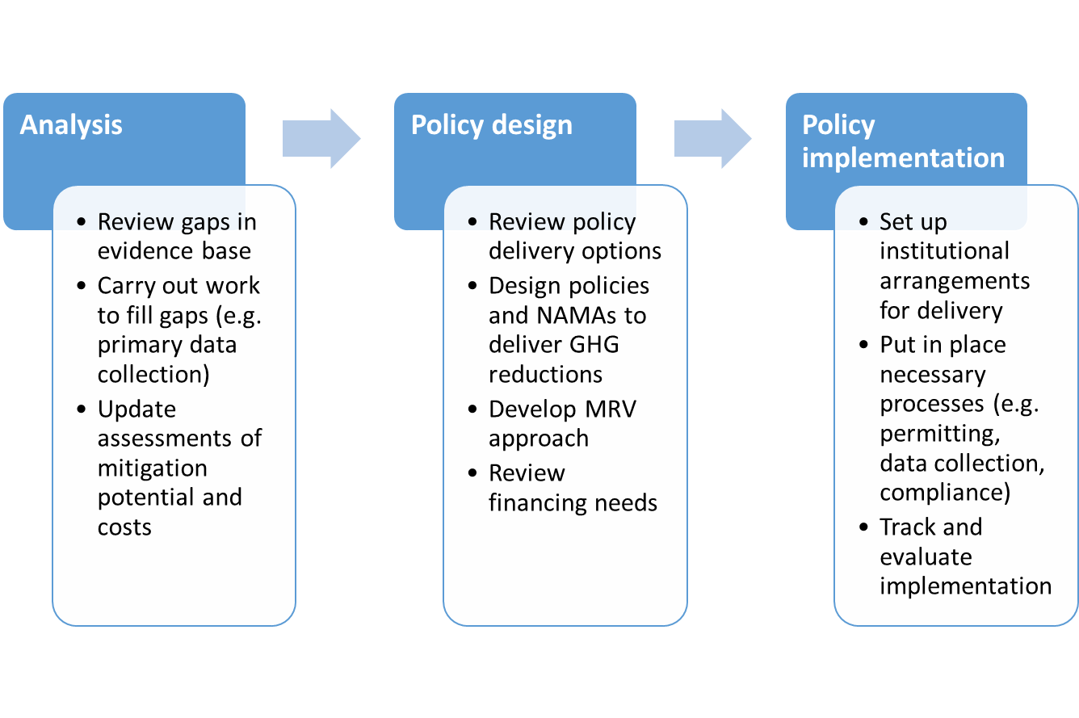

## Capacity building for mitigation

To carry out the above, capacity will need to be built in a number of areas, as follows:

### Analytical capacity:

Whilst there is considerable scope for improving the climate change analytical and evidence base in Bangladesh, this should not be an impediment to taking action now to tackle GHG emissions. However, the Government will look to implement a parallel programme of improvements to the underpinning analysis on climate action in Bangladesh. This will take many forms, varying from sector to sector and measure to measure.

Table : Capacity challenges for mitigation

|  |  |  |
| --- | --- | --- |
| **Issue** | **Challenge** | **Solution** |
| Data archiving | Lack of consistent archiving of data on mitigation, e.g. from NDC, National Communications, other reports etc. | MoEF will initiate a system of electronic data archiving to keep all mitigation-related data in one place. This could form the basis for the eventual MRV system (see Section 7 for more details) |
| Data sets | Lack of data, data not statistically robust, reliance on extrapolation and interpolation. | MoEF will seek international support for a comprehensive data review across all sectors, to identify the gaps and weaknesses and to help develop more robust data (e.g. through primary data collection surveys). |
| Modelling capacity | Lack of capacity on key modelling approaches, such as Marginal Abatement Cost Curves, the LEAP model etc. | MoEF will seek international support for a capacity building project to build understanding of key mitigation modelling techniques and methodologies. |

### Policy capacity

An important next step will be for the Government to start designing specific policies to deliver the mitigation potential outlined by the analysis mentioned above. This will require knowledge of policy approaches such as feed-in tariffs, efficiency standards and green procurement etc. Considerable expertise in such policy options already exists, both within Government and also outside, for example in academia. But the Government will look for further opportunities to increase understanding on such policy options, through technical cooperation with other countries to share best practice and experiences.

A specific area for further capacity development in this respect is around the development of impact assessments. Bangladesh will consider options for introducing an impact assessment process whereby any new policies are required to produce standard information on expected impacts, including GHG reductions, before being signed off by Ministers. This will ensure that a clear understanding is reached in advance of what the policy is expected to deliver and will aid future decisions about whether to amend the policy in future to make it more effective. It will also help screen non-climate policies to better understand what their likely GHG impacts will be, before taking decisions.

### Technical capacity

It will greatly benefit Bangladesh economically if it is able to capture the benefits and opportunities to encouraging economic growth from NDC implementation. However there is limited local manufacturing facilities and capacity, as well as limited technical capacity to design, install, operate, manage and maintain renewable energy and energy efficiency services.

It is proposed that technical assistance support is sought for the private sector to build the required capacities. One option for this could be the Private Sector Facility of the Green Climate Fund (see Section 6 for more information).

# Adaptation

Climate change adaptation is a key priority for Bangladesh and the country has already undertaken initiatives to mainstream adaptation into national development such as in the water, health, forestry, agriculture and more prominently in the infrastructure sectors. Bangladesh is already experiencing a host of climate impacts, including floods, storm surges, drought and river bank erosion. With an average elevation of 4 to 5 meters above mean sea level, nearly a third of the country is susceptible to tidal inundation and nearly 70% gets flooded during heavy monsoons. About 10% of the country is only 1 meter above the mean sea level, and one-third is under tidal excursions. Besides, the Bangladeshi economy is based predominantly on agriculture, forestry, and fishing. As a result, climate change is expected to decrease agricultural GDP by 3.1 % each year, a cumulative 36 billion USD in lost value-added for the period 2005-2050.

According to the Fifth IPCC report published in 2014[7], the framing of adaptation has moved further to the wider social and economic drivers of vulnerability and people’s ability to respond. There is disagreement about what developing countries should do to protect themselves [Millner and Dietz, 2015]. Categories of adaptation options have been provided. Engineered and technological adaptation options are still the most common adaptive responses, although there is growing experience of the value of ecosystem-based, institutional, and social measures for those who are most vulnerable. Such options could include building embankments in coastal areas, building high elevation roads, bridges and culverts to protect the road communication network in the event of seasonal flooding and building groynes to protect river banks from erosion. Water, sanitation and hygiene (WASH) have a significant impact on health and, of particular concern as described in the recent Intergovernmental Panel on Climate Change Special Report on Extreme Events, are the risks of more frequent and intense extreme weather events such as floods, cyclones and droughts, alongside increasing temperatures. Such extremes pose particular challenges to the capacity of WASH programmes to protect health, and there is accumulating evidence that climate change is worsening these risks.

Bangladesh’s major adaption domains are set out in Figure 3. Most of the adaptation items are interdependent with each other. Issues like water security have a direct relationship with health and livelihoods and has a passive relationship with the social-safety net. Climate resilient infrastructure has a major role to play to prevent river bank erosion and saving coastal population lives from tidal surges and salinity intrusion. So to be combated properly, tackling adaptation demands an integrated policy, institutional and funding support regime associated with huge capacity support. To do this, the Government of Bangladesh has decided to streamline the National Adaptation Plan (NAP) process with other climate change related frameworks and commitments to deal with adaptation issues in an integrated manner.

Figure 3: Major Adaptation domains of Bangladesh



For the last decade, Bangladesh has taken a strong leadership role on adaptation. Bangladesh has not only introduced some innovative and integrated approaches to tackle adaptation in vulnerable communities, the nation has also actively mobilized significant resources to tackle the challenges of adaptation and bio-diversity and conservation. Moving forward, Bangladesh needs sufficient financial support from international sources to tackle the adverse impact of climate change.

Taking climate vulnerabilities into consideration, the Government of Bangladesh has identified the following areas of interventions and adaptation priorities to address the adverse impacts of climate change.

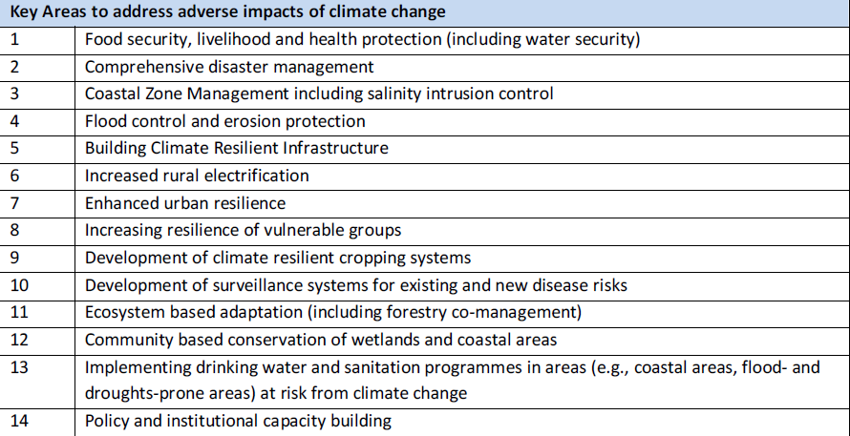

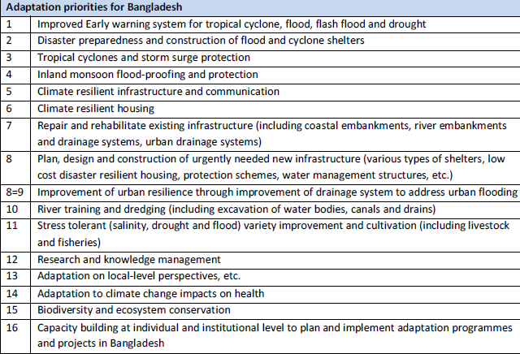

## The overall NAP process

Adaptation policy and implementation in Bangladesh is being driven by the NAP process. Nonetheless, this NDC Implementation Roadmap and the accompanying NDC Sectoral Action Plans for power, industry and transport, take account of adaptation by attempting to prioritise measures and actions that will have both mitigation and adaptation benefits, as well as by setting out how the three sectors are likely to be impacted by climate change and how they can take actions to address this.

The NAP process was established under the Cancun Adaptation Framework. It enables countries to formulate and implement NAPs as a means of identifying medium- and long-term adaptation needs and developing and implementing strategies and programmes to address those needs[8]. Technical Guidelines[9] have been produced by the LDC Expert Group for the NAP process and sets out the key steps of the process:

* Element A: Lay the groundwork and address gaps
* Element B: Preparatory elements
* Element C: Implementation strategies
* Element D: Reporting, monitoring and review

A roadmap for developing the NAP was prepared in 2015, supported by the Norwegian Government. Institutional arrangements have been set up for the NAP process, through the formulation of an Inter-Ministerial Steering Committee, a Technical Advisory Committee and a core NAP formulation team. In terms of current work, the German Government is supporting MoEF to carry out countrywide vulnerability assessments, both by district and by hotspot (e.g. specific vulnerable areas).

Further work will be carried out to support the NAP process, including an exercise to model future climate scenarios, updates of projections of key parameters (e.g. population, employment growth, economic growth etc.) and comprehensive vulnerability analysis of key sectors.

The NAP process will continue to be the primary forum for taking forward action on adaptation. The NDC implementation process, via the NDC-NAP Implementation Coordination Committee, will liaise regularly with the NAP process to discuss synergies and to ensure a joined-up approach.

Each NDC Sectoral Action Plan describes (a) how that sector is impacted by climate change (and what the risks might be to the sector going forward) and (b) what that sector can do to strengthen climate resilience, both within that sector and more widely. In addition, the Government of Bangladesh will continue to prioritise measures, such as solar irrigation in the power sector, that can deliver both mitigation and adaptation benefits. Indeed, climate resilience will be one of the key criteria used in any prioritisation and shortlisting of mitigation measures, alongside other important criteria such as cost, mitigation potential, technical feasibility and co-benefits.

## Major sectoral impacts, vulnerability and adaptation to climate change

The NDC implementation sectoral action plans for the power, industry and transport sectors contain information on how those sectors are likely to be impacted by climate change and what they can do to strengthen their resilience to climate change in the future. This section of the roadmap now considers a number of other sectors that are highly relevant when it comes to adaptation in Bangladesh. The section first runs through these sectors to assess how they are impacted by climate change. It then considers previous action on adaptation, possible future actions and likely costs.

### Agriculture and food security

Based on socioeconomic projections, geographical location and future hazards, Yohe et al. (2006) concluded that Bangladesh will be extremely vulnerable to climate change under all scenarios, including a scenario combining mitigation and enhanced national adaptive capacity. Although in the last four decades, the agriculture sector has made very significant progress in crop production and food insecurity management through interventions (agriculture and fiscal) in the risk prone areas, these gains could be threatened with changes in climate and associated extreme hazards as well as intrusion of saline waters in the coastal areas due to sea level rise. Some of the reasons for concern for the agriculture sector in Bangladesh are briefly summarized below:

* Temporal and spatial distributional changes of water resource can harm the agriculture sector.
* There will be significant changes in land classes that are widely used for crop production.
* Global mean temperature increase and the increased frequency and/or severity of extreme weather events can increase agricultural sector losses.
* Climate Change, sea level rise and intrusion of salinity can increase loss of agricultural lands and food insecurity in the coastal region.

### Water security in Bangladesh

The water sector in Bangladesh will be highly vulnerable to the changes in climatic parameters, such as temperature and precipitation; frequency, intensity and magnitude of extreme events, and rising sea levels. Human interventions in large shared river basins may lead to further complexity. Below are the key climate change vulnerabilities for the water resource sector in Bangladesh.

* Melting glaciers in the Himalayas is a concern for Bangladesh’s water supply, especially in the dry season. Due to high variability of seasonal water supplies, dry season water is vital for supporting ecosystems, agriculture and fisheries and water navigation. The IPCC (2014)[10] projected 45% and 68% Himalayan glacier loss by 2100 under RCP4.5 and RCP 8.5 scenario[11], respectively. However, due to melting, in the first few decades, water supplies will increase but later it will decrease due to shrinkage of the glacier mass. Sediment supply in the Ganges and Brahmaputra rivers could increase in the dry season that may result in siltation and loss of capacity of the channels.
* Rate of evaporation from the soil, open water and plants would increase due to rises in temperature. Therefore, soil storage would capture the larger amount of infiltrated water. This would result in reduction in deep percolation to shallow aquifers as the upper limit of infiltration is limited by soil type. As a result, groundwater recharge is likely to be reduced (Farquharson et al., 2007).
* Future rates of sea-level rise are expected to increase coastal flooding, erosion, and saltwater intrusion into surface and ground waters (IPCC, 2013).
* Increased temperature and higher rates of soil moisture loss could lead to longer and high impact droughts in the country.

### Health

A changing climate impacts on health and well-being but it can be difficult to determine the degree of complexity, scale and directness. Consequently, as a function of vulnerability of the local population i.e. rural areas of Bangladesh and geography and environment, the impacts would also vary (Michael, 2003). Due to important interactions with ecological and social processes, it would be difficult to determine the contribution of environmental and biological influences of climate change on health (Githeko and Woordward, 2003). The changes in exposure to heat waves, winter cold, increases in floods, cyclones, storm surges, droughts, increased productions of air pollutants and aeroallergens like spores and molds are all considered to have more direct impacts on health in Bangladesh in terms of lives lost, injuries, and disease outbreaks (Michael, 2003). More than 12.4% of the domestic heads of Sundarbans community, which are particularly vulnerable to climate change, have suffered from illness and 28.5% of the same category has fallen into accidents due to these natural calamities (Masum, 2012). World Bank (2014) concludes, “According to data collected by the European Detailed Mortality Database, between 1980 and 2010, Bangladesh experienced 234 natural disasters, causing more than US$17 billion in total damage. The total number of people killed as a result of natural disasters between 1980 and 2010 was about 191,836; on average, 6,188 people are killed each year[12]. (World Bank, 2014, p.18-19).

### Fisheries

Fish physiology i.e. growth, reproduction, metabolism etc are directly influenced by changing temperature (Chowdhuryet. Al.2010). Temperature extremes and erratic rainfall have direct impact on fish physiology, growth, mortality, reproductive system, feeding behaviour, production and migration in inland and marine waters. High temperatures may induce growth of aquatic microphytes. Higher production of microphytes can reduce productivity of water, and causes habitat degradation and oxygen depletion. Indirect impacts of climate change on fish are the changes and effect on the fish habitat/ecology on which fishes depend for food and shelter (Mustafa, 2010). High/extreme temperature may affect physical and chemical parameters of water affecting fish physiology, migration, growth, reproduction etc. Temperature rise may affect distribution patterns of some marine fishes and they may migrate to higher latitudes for cooler water (Chowdhury, 2010). Increase of environmental temperature activates physiological activity of fish demanding more oxygen and ultimately depleting dissolved oxygen in water which hampers growth and the reproduction system of fish. Due to high temperatures and erratic/insufficient rainfall, fish do not ovulate properly and eggs are not fertilized properly and hatching rates become low. This would ultimately result in lower fish stocks, which would impact on livelihoods and on the fishing industry.

### Livestock

The change of climate has both direct and indirect impacts on livestock. Global climate change is expected to alter temperature, precipitation, atmospheric carbon dioxide levels and water availability in ways that will affect the productivity of crop and livestock systems (Hatfield et al., 2008). Sea level rise will inundate new coastal areas, which will affect livestock by reducing grazing areas and fodder production. Like human beings, livestock and poultry may suffer due to natural disasters, higher temperatures, salinity intrusions and floods. As compared to other sectors, there are very few economic analyses done on the climatic effects on the livestock sector worldwide. The most important impacts of climate change in the livestock sector are reduced grazing areas, fodder crisis, reduced growth and decrease in production of milk, meat and eggs. In 2007 cyclone SIDR hit 17 districts in the coastal region of Bangladesh. The cyclone’s surge was over 5 meters. There was enormous loss to livestock due to that catastrophe. The preliminary damage and loss assessment for crops, livestock, and fisheries is estimated to be BDT 30.2 billion (US$ 437.6 million), of which BDT 1.5 billion (US$ 21.3 million) is damage to assets and BDT 28.7 billion (US$ 416.3 million) is production loss[13].

### Livelihood

The five categories of livelihood assets/capitals - natural, physical, financial, human and social - are adversely affected by different climatic events. For example, flood, cyclones, river erosion etc can cause damage to:

* Infrastructure, housing (physical capital);
* Land, crop, forest, fresh water (natural capital);
* Wage and income (financial capital);
* Sickness and school dropout (human capital); and
* Forced migration, disintegration of family structures (social capital).

Sea level rise, cyclones and salinity cause land loss, land degradation, contamination of water etc. forcing millions to leave their habitat. River erosion is a serious threat to the population living near the banks of major rivers who may become shelter less, landless and may lose all their livelihood assets. Most of the victims of river erosion become internally displaced people. Having lost all livelihood assets they fall into the trap of perpetual poverty.

### Forest, biodiversity and ecosystems

Increases in temperature, precipitation, salinity and extreme weather events such as floods, cyclones and droughts of a tropical country like Bangladesh will create negative impact on forests (MOEF, 2016; IPCC, 2001). According to a projection, by 2050 the Sundarbans will be permanently inundated due to rise in sea levels. As a result, the swamped vegetation will gradually die and the rotting vegetable will give rise to release of more detritus, which will primarily boost up the aquatic population; all the terrestrial fauna in this mangrove forest will possibly move towards the North and then disappear, meaning that the composition of aquatic fauna is likely to alter. Inundation is one of the resultant effects of the rise in sea level, which will lead to death of species that do not thrive under higher inundation. This will result in the loss of habitat of fauna and elimination of water holes which supply water for forest wildlife and in turn, the number of tigers will also decline due to shortage of prey in the jungle. This mangrove ecosystem is likely to experience higher salinity due to sea water flow inside the forest and the low salinity zone or fresh water zone of the northern part of the Sundarbans will possibly get obliterated by endangering the ecosystem. The decrease in the quantity of Sundri trees (Heritiera Fomes) is one of the consequences of the presence of the saline water in mangrove forests.

Along with global sea level rise, the continuous natural subsidence in the Sundarbans is causing a net rise of 2.2 mm per year in sea level in these areas[14]. The IPCC is forecasting that the droughts and floods will get worse, which will eventually submerge the Sundarbans. They also believe that 75% of Sundarbans mangroves will be destroyed due to rise in seal level combined with the other forms of anthropogenic stress on Sundarbans. The supporting services of the Sundarbans include acting as a habitat for plants and animals, pollination, nutrient cycling, and acting as a nursery ground for fisheries and wildlife. These changes in the supporting services will have visible effects on the provisioning services of Sundarbans, such as timber, fuel wood, fish, thatching materials, honey and waxes.

## Adaptation actions past and present

Over the last three decades, the Government of Bangladesh has invested over $10 billion (at constant 2007 prices) to make the country more climate resilient and less vulnerable to natural disasters. Flood management embankments, coastal polders and cyclone shelters have been built, and important lessons learnt on how to implement such projects successfully in the dynamic hydrological conditions of Bangladesh and with active participation of communities. To enhance climate change adaptation activities in all key policies and sectors, Bangladesh established two innovative funds: the Bangladesh Climate Change Trust Fund (BCCTF) from the Government’s own budget and the Bangladesh Climate Change Resilient Fund (BCCRF) with the support of development partners. Bangladesh submitted the National Adaptation Programme of Action (NAPA) in 2005 (revised in 2009) and prepared the Bangladesh Climate Change Strategy and Action Plan in 2009.

The CCT under MoEF has undertaken 441 adaptation and mitigation projects with support from the BCCTF. Of the total, 378 projects were/are being implemented by government organizations. Non-Governmental Organisations/Civil Society Organisations through Palli Karma-Sahayak Foundation (PKSF) implemented the remaining 63 projects. Over the last 7 years, the major adaptation investments were on infrastructure development, especially construction/reconstruction of the polders/embankments, afforestation, river dredging to ensure water flow in the rivers, drainage infrastructure in urban areas, climate resilient housing for vulnerable communities, water supply and sanitation and climate resilient agriculture. Bangladesh Water Development (BWDB) under the Ministry of Water Resources (MoWR) received the highest resources from BCCTF for construction and reconstruction of embankments/polders and water infrastructure under the Comprehensive Disaster Management and Infrastructure thematic pillar of the BCCSAP. The Local Government and Engineering Department (LGED) and Department of Public Health and Engineering (DPHE) implemented a number of adaptation projects related to drainage system and water supply and sanitation services. Department of Environment (DoE) took the lead on mitigation and some adaptation projects. Department of Forests (DoF) was awarded the afforestation/reforestation projects besides the coast, urban areas and other places e.g. parks. The Department of Agriculture Extension (DAE), Bangladesh Agriculture Development Corporation (BADC), Bangladesh Rice Research Institute (BRRI) and Bangladesh Institute of Nuclear Agriculture (BINA) implemented projects on agriculture related issues. Bangladesh Rice Research Institute (BRRI) and Bangladesh Institute of Nuclear Agriculture (BINA) initiated research on climate resilient varieties. Since 2010, a number of climate tolerant varieties have been invented by the above mentioned research organizations.

In Bangladesh, disaster risk reduction and climate change adaptation in some cases is now an integral part of national development strategy. New legal and institutional frameworks for disaster risk reduction and climate change adaptation have been established. Disaster and climate change sensitive sectoral development strategies, norms and standards (e.g. urban development, water management, natural resource management, and infrastructure) have also been adopted. Social safety net programs have been strengthened for building resilience to cope with disasters and anticipated climate impacts in Bangladesh. Cooperation and collaboration in disaster risk reduction and climate change adaptation have been strengthened at some level among government and non-government actors in the areas of land-use planning, city emergency management, early warning message dissemination, community based disaster preparedness, etc. Post-disaster needs assessments are undertaken in the aftermath of a disaster to accelerate resilient recovery (CDMP, 2013). The Ministry of Food and Disaster Management (MoFDM), as the ministry primarily responsible to serve the country in addressing disaster risk reduction, has taken up the Comprehensive Disaster Management Programme (CDMP) to address capacity building and mainstreaming as key areas of support toward making the country and its development resilient. In line with this, an initiative has been taken to develop mechanisms to mainstream DRR and CCA into development planning and processes. As part of this, a “Guide to Practice” has been drafted to facilitate the operation of the integration process into ministries, agencies and departments (MoFDM, 2009). The following activities have been identified by this process as immediate actions.

* Understanding disaster and climate risks;
* Contextualizing risks in relation to sectors and concerned agencies/departments;
* Exploring the range of disaster and climate risk reduction options in relation to mandated goals and targets;
* Identifying priorities, needs, gaps, cross- and inter-sectoral linkages;
* Planning to address these priorities, needs, gaps, cross- and inter-sectoral concerns;
* Mobilizing resources: internal and external; and
* Reviewing and monitoring disaster and climate resilient activities, programmes and projects and feedback to mainstream processes.

### Potential adaptation actions

Potential adaptation measures, regarding different sectors that affect human lives and livelihoods, such as water, agriculture, health, and transport, have been formulated in the tables in Appendix 2, and taken from various documents including the Third National Communication and the Bangladesh Climate Change Strategy and Action Plan. These adaptation measures are further classified as engineering or non-engineering based, based on their nature and technicalities.

### Cost of adaptation

Significant investments will be required to address climate impacts, including developing early warning systems for floods and cyclones, improved irrigation and water management, improved operation and maintenance and upgrading of coastal embankments and polders and upgrading of flood protection embankments/drainage systems. Adaptation cost estimates for all related sectors have not been done at length for Bangladesh. The World Bank in 2010 estimated that by 2050, the investment costs of tropical cyclones and storm surges alone will be USD 5.5 billion and the annual recurrent cost will be USD 1.1 billion, whereas for inland monsoon flooding the investment cost will be $2.7 billion and the annual recurrent cost will be USD 54 million[15]. The cost of climate related diseases and conditions, like Diarrhoea, Kalazar, Filariasis, Dengue/Malaria Chikun gunya and chronic obstructive pulmonary diseases, would cost around USD 4.01 billion for the 15-year period (2015-2030) which is equivalent to USD 272.1 million per annum. Bangladesh has already implemented some key adaptation activities based on urgent and immediate needs of the country. Implementation of identified adaptation measures is critical to increase the resilience of the country to climate change. In the NDC it was estimated that Bangladesh will need to invest USD 42 billion from 2015 to 2030 to implement the identified adaptation measures in the tables in appendix 2 to address adverse impacts of climate change from tropical cyclones, monsoon flooding and climate related diseases. Bangladesh will seek to access monetary support from the adaptation fund and other relevant international financing windows to support the implementation of the major adaptation measures with immediate priority.

# Resourcing the plan

Implementing the NDC will require considerable resources, in particular in the form of climate finance. Indeed, as stated in the NDC itself, the delivery of the more ambitious target to reduce GHG emissions by 15% below business-as-usual emissions in 2030 in the power, transport and industry sectors, is conditional on Bangladesh receiving adequate support from the international community. And support will be needed not just for new technologies and infrastructure, but also for capacity building, further analysis, data collection and policy support.

The NDC Sectoral Action Plans provide information on resourcing needs for specific sectors. This roadmap explains the overarching approach and next steps required on climate finance.

In Bangladesh there are diverse intermediaries, instruments and planning systems in Bangladesh’s financial landscape. Although they all play a role in mobilising and channelling resources to climate-related investments, disbursement is fragmented. Between 2009 and 2013, Bangladesh needed US$5 billion of investment in climate-related initiatives, but only leveraged USD 1 billion, mainly due to barriers to accessing the funds (with donors committing to funding but those funds not necessarily being mobilised). To minimise this deficit and maximise opportunities, it needs to establish local financial intermediaries to complement existing intermediaries, use innovative economic and financial instruments and use financial planning systems to ensure better synergy across the financial landscape (TIB 2013).

On the other hand, the resource plan for adaptation will be based on the forthcoming National Adaptation Plan, while taking input from the National Sustainable Development Strategy, the Perspective Plan (Vision 2021), the Seventh Five Year Plan, the National Disaster Management Plan, the Disaster Management Act and the Country Investment Plan of Bangladesh on Environment, Forestry and Climate Change. Bangladesh has identified, USD 42 billion to be required to implement the adaptation measures identified in the NDC. Bangladesh will look to funding from sources like the Green climate fund, the Adaptation Fund and the Least Developed Countries Fund to address the identified adaptation measures.

## The climate finance landscape in Bangladesh

Most climate finance in Bangladesh to date has been targeted at adaptation and climate resilience, as would be expected bearing in mind the country’s vulnerability to climate change. Nonetheless it is useful to understand the existing climate finance landscape in Bangladesh as the same structures and processes are likely to be used to fund NDC and NAP implementation and the mitigation activities to deliver it.

National funding for climate activities is channelled and accessed through the Bangladesh Climate Change Trust Fund, allocated a total of USD 340 million from the national budget. 66% of the Fund’s projects are aimed at enhancing Bangladesh’s adaptation capacity, comprising a large number of small-scale projects (under USD 2.5 million) across the country. Projects are implemented by government bodies as well as non-governmental and civil society organisations, research institutions and the private sector. The remaining 34% is kept as a fixed deposit, earning interest for emergency projects and programmes. Government agencies drawing from the Fund are accountable to the Ministry of Finance for financial compliance and the Trust Fund for the submission of project completion reports. NGOs, research institutions and private sector actors are accountable to the Palli Karma Sahayak Foundation, which is in turn accountable to the Trust Fund through its secretariat, the Bangladesh Climate Change Trust. So far 139 government projects and 63 non-government projects have been approved, to a total of USD 190.78 million.

The Bangladesh Country Investment Plan (CIP) provides a coherent set of 12 priority investment programmes to improve food security and nutrition in an integrated way. The total cost of the CIP is estimated at USD 7.8 billion. Of this, USD 2.8 billion are already financed through allocated Government budget resources and contributions by Development Partners. The financing gap is therefore USD 5.1 billion, of which USD 3.4 billion has been identified as first priority requirements. The CIP was a five year plan aligned with the 6th Five Year Plan for 2011-2015 of the Government of Bangladesh. It describes itself as a living document and is therefore aligned now with the latest five year plan.

National private finance is provided through the Central Bank and commercial banks who offer concessional loans and refinancing, guided by the policy guidelines for green banking (2011).

International funding for climate activities comes from a range of sources and via various mechanisms. Some examples include:

* Green Climate Fund – Bangladesh is targeting the GCF for support for mitigation and adaptation actions. The Economic Relations Division in the Ministry of Finance has been designated as the National Designated Authority (the national focal point for the GCF in Bangladesh) and they have submitted a proposal to the GCF for building GCF readiness, for example by strengthening the country coordination mechanism for GCF-related activities and identifying transformational investment opportunities in accordance with GCF’s Investment Framework and Result Management Framework[16]. Thus far, Bangladesh has received USD 40 million from the GCF for climate resilient infrastructure mainstreaming in Bangladesh, with a further USD 40m of co-funding from the German Ministry for Economic Cooperation and the Bangladeshi Ministry of Local Government[17].
* Bilateral funding sources:
  + The NAMA Facility, set up by the UK and German Governments and now also supported by the Danish Government and the European Commission, could be a source of funding for mitigation action.
  + Japanese bilateral funds are routed directly to government agencies via the coordination of the Economic Relations Division.
* International multilateral funding includes:
  + The Pilot Program for Climate Resilience.
  + The Global Environment Facility’s Least Developed Countries Fund.
  + The Global Environment Facility’s Trust Fund.
  + The UN REDD+ Programme.

It is important to recognise that Bangladesh has aspirations to become a middle income country by 2021 and that once it stops being classified as a Least Developed Country, certain funding options will no longer be available to it, such as the GEF Least Developed Countries Fund mentioned above.

As well as considering funding sources, Bangladesh should look to make maximum benefit from collaborations and groups that can help facilitate access to funding. Examples include the NDC Partnership[18], which Bangladesh is already a member of, and the International Solar Alliance, the Framework Agreement of which Bangladesh has signed. Bangladesh may also seek to participate in and benefit from other such groups, such as the Initiative for Climate Action Transparency, supported by philanthropic foundations and the German and Italian governments, which could help provide technical support and capacity building on MRV.

## Oversight and coordination

The focal point for financing of NDC implementation will be the MoEF, working closely with the Economics Relations Division in the Ministry of Finance. The MoEF team will be responsible for:

* Strategic planning and coordination of the access, mobilisation, disbursement and tracking of climate finance across the country.
* Establishing and maintaining communication with government focal points and with bilateral and multilateral funders.
* Ensuring coordinated engagement with funders via these government focal points.
* Disseminating information to country stakeholders regarding funding criteria and the operational requirements and procedures of major funders.

As outlined in the second point above, a number of government focal points will be established who will manage relationships with the important bilateral and multilateral funders for mitigation (and adaptation) projects.

## Developing more accurate costings for the NDC

The NDC itself, as well as the NDC Sectoral Action Plans, provide some illustrative costs of individual activities and measures. But as recognised in the NDC, more work is needed to accurately assess the scale and scope of investment needs for mitigation and adaptation activities. This will involve a comprehensive desk review of existing cost data, both from Bangladesh but also from international case studies, as well as gathering of new data on costs to help improve the evidence base in Bangladesh. Any cost data collected should include upfront capital costs, ongoing maintenance and operational costs as well as any other costs such as capacity building, training, information etc. Doing this will also involve a considerable consultation exercise with national experts to gather data and to verify estimates.

It is also suggested that capacity be built to allow for a periodic reassessment of costs of mitigation actions. This is important as costs are likely to change over time (e.g. falling costs of a new technology) and also new information and data may become available to provide more accurate estimates.

## Assessing funding options

There are a range of possible options for funding the implementation of the NDC, including but not limited to some of those mentioned above, such as the GCF and bilateral support. Other sources include:

* Nationally Appropriate Mitigation Actions – Bangladesh is currently developing a number of NAMAs and these offer the potential to receive international support.
* ‘Climate-proofing’ of existing national budgets, such as infrastructure spend.
* New international funding arrangements, such as the Capacity Building Initiative for Transparency, which could support MRV work in Bangladesh.
* Further engagement with the private sector.

### International bilateral and multilateral funding sources

A full review will be carried out to consider Bangladesh’s history of accessing funds from bilateral and multilateral sources to identify potential funders with whom the country already has a relationship. The review will also identify any new sources of multilateral and bilateral finance that could potentially support the actions set out in the NDC and the NDC implementation sectoral action plans.

The eligibility of each action against the funding criteria for existing and potential new bilateral and multilateral funding sources will then be assessed and a decision taken on the best method for the country to access each funding source, for example direct access and indirect access, or NAMA development (see below).

### Nationally Appropriate Mitigation Actions

Nationally Appropriate Mitigation Actions (NAMAs) offer a clear route to accessing international support. NAMAs can be submitted to the UNFCCC’s NAMA Registry[19], which helps match mitigation actions that are seeking support with available funding from international donors. The type of support that is most suitable will depend on the nature of the barriers to carrying out the mitigation action. For example, where the barrier is a low return on investment, financing options such as direct subsidies, feed-in tariffs and carbon market approaches are likely to be most appropriate. Where the barrier is high up-front capital costs, then provision of debt (e.g. through loans or credit lines) or provision of equity are likely to work best[20].

For NAMA financing to be a viable route for Bangladesh, it will be important that the country is able to offer sufficiently detailed data on the expected impacts and how these will be tracked. Hence the importance of sound MRV approaches for each NAMA, including a forecast of the likely GHG emissions reductions and other non-GHG impacts against which progress can be measured.

### Climate-proofing of existing national budgets

There is huge potential to ramp up investment in climate activities by ‘climate-proofing’ existing budgets, to ensure that activities that are being funded are carried out in a way that maximises the climate benefits. This includes activities such as::

* Reviewing existing development policies, programmes and infrastructure project pipelines to assess the potential for ‘greening’ these activities, for example extending or amending these to include NDC priorities, and screening the climate risks or mitigation potential associated with these projects.
* Identifying opportunities to mainstream climate change priorities into the national budgetary and infrastructure planning process.
* Considering what information on the co-benefits of climate action might be useful to these departments, to obtain buy-in and support for climate-proofing of existing budgets.

A Climate Public Expenditure and Institutional Review (CPEIR) was carried out by UNDP and others in 2012. This included an exploratory review on how climate change-related expenditure is being integrated into the budgetary process in response to national policy setting in Bangladesh. This found that the Government of Bangladesh typically spends around 6-7% of its annual combined budget on climate sensitive activity[21].

### New international funding arrangements

The Capacity Building Initiative for Transparency is still in its infancy and modalities and procedures are still being discussed at the international level. The Government of Bangladesh will consider the role that the CBIT might play in developing a national MRV system (see MRV section below).

### Further engagement with the private sector

Work has been carried out looking at the business case for the private sector in Bangladesh to invest in climate change and access international climate finance[22]. This shows that climate change offers both risks and opportunities for the private sector. A number of businesses in Bangladesh are already benefiting from new opportunities related to tackling climate change. For example, by developing new technologies, accessing new markets and taking advantage themselves of cost savings from efficient technologies. That said, to encourage scaled-up investment by the private sector in Bangladesh in climate-related activities, certain barriers need to be addressed, including lack of information, lack of access to finance and capacity constraints.

One way of addressing some of these barriers is via the Green Climate Fund’s Private Sector Facility, a dedicated financial window to mobilise and channel private capital and expertise at scale. Work is currently ongoing to build readiness in the private sector for GCF accreditation. This will allow it to directly access this source of funding, enabling it to engage in adaptation and mitigation activities, scale-up projects, boost innovation potential, reduce vulnerabilities and harness untapped opportunities[23].

## Measurement, reporting and verification (MRV) of climate finance

Crucial to successful leverage of climate finance for NDC implementation will be a clear and robust mechanism for ensuring transparency and accountability. Such a mechanism should allow for tracking resources received and the sources of the revenue, as well as policy measure and project-level spend, linking the two together for full transparency.

The mechanism would be managed by MoEF. The key next steps to setting up such a mechanism are:

* Review any finance MRV systems that are already in place and that could form a basis for the MRV of climate finance.
* Develop standard methodologies and key performance indicators for a climate finance MRV system (including agreeing a definition of what constitutes climate change-related activities).
* Develop a central tracking system that allows users to input data using standard templates.
* Carry out a mapping exercise to understand all the relevant institutions that are likely to receive climate finance, and put in place data-sharing agreements (e.g. memoranda of understanding) between them and ERD, setting out what data will be shared and under what conditions (e.g. frequency of reporting, format for reporting etc).
* Process and analyse data on a regular basis, delivering findings in a report for national and/or international audiences.

## NDC implementation activities: finance

|  |  |  |  |
| --- | --- | --- | --- |
| *Activity* | *Responsibility* | *Timeline* | *Indicative cost / resource needs* |
| ***Finance*** | | | |
| *Set up institutional arrangements on climate finance* | *ERD, working with DoE* | *September 2017* |  |
| *Development of more accurate costings for mitigation measures* | *ERD* | *August 2017 to September 2018* | *Est 15m BDT* |
| *Detailed review of funding options* | *ERD* | *June 2017 to November 2017* |  |
| *Drafting of detailed Climate Investment Plan* | *ERD* | *October 2017 to July 2018* | *Est 20m BDT* |
| *Gap analysis of current finance tracking systems and institutions* | *ERD* | *August 2017 to November 2018* |  |
| *Develop central tracking system for climate finance, with standard methodologies* | *ERD* | *September 2017 to July 2018* |  |

# Measurement, reporting and verification (MRV)

Transparency, also known as measurement, reporting and verification (MRV), is central to the Paris Agreement and NDC implementation. In the context of NDCs, it refers to the process by which countries track and report on progress towards the NDC’s targets, the implementation and impacts of mitigation and adaptation actions, and the finance used to support these actions[24]. The Paris Agreement requires each Party to the Agreement to regularly provide (a) a greenhouse gas emissions inventory, (b) information necessary to track progress towards its NDC, (c) information on climate impacts and adaptation and (d) information on support needed and received[25]. All Parties, except Least Developed Countries (LDCs) and Small Island Developing States, shall submit this information no less frequently than every 2 years (LDCs and SIDS can submit at their discretion). So whilst there are currently no specific requirements or deadlines for Bangladesh in relation to MRV at the international level (due to its LDC status), over time it will, under the Paris Agreement, need to start producing every 2 years the information described above. Furthermore, it is important that Bangladesh considers what information will be useful not just for international reporting but also for a domestic audience, to assist transparency and engagement on NDC implementation.

It is important however not to consider MRV as a new requirement. Like most countries, Bangladesh will already have many key elements of an MRV system for NDCs, through existing reporting on policies and projects for various audiences. In some cases, this can be adapted to meet the needs of reporting on progress in implementing and achieving the NDC, and as such, an important first step is to review existing reporting processes and structures to consider what data is already collected and that could be used for MRV of NDC implementation. This would include the GHG inventory, reporting by the Bangladesh Bureau of Statistics but also any policy reporting done by individual government ministries.

## The GHG inventory

The NDC contains a target to reduce GHG emissions in the power, transport and industry sectors by 5% below business-as-usual emissions for those sectors in 2030, rising to 15% upon conditional of adequate international support being received to support mitigation actions. The main approach for tracking progress towards these targets will be regular updates to Bangladesh’s greenhouse gas inventory. These will show the extent to which GHG emissions are changing across the whole economy and in individual sectors.

Bangladesh is currently in the process of compiling a national GHG inventory covering the years 2006-2012. For the first time DoE assigned their staff to work with local consultants, allowing for capacity to be built within the Department. This will increase continuity for future GHG inventory compilation cycles, e.g. by allowing to establish data collection processes including data sharing agreements with data providers and contribute to improvement over time, e.g. covering emissions from fluorinated greenhouse gases, which are not covered in the inventory currently under compilation. Once the current inventory compilation has been completed, the team can develop a plan of desired improvement steps and realistically plan the implementation of these steps over the coming years, based on the resources available.

## GHG projections

However, whilst the GHG inventory can provide a tool for evaluating trends in GHG emissions as an ex-post exercise, relying on this will not provide sufficient timescales for planning to address any concerns regarding the 2030 target. For example, if GHG emissions are reviewed in 2018, and the data suggests that Bangladesh is not appropriately on track towards the 2030 targets, then the Government may wish to consider additional policy measures to further reduce GHG emissions in the power, transport and industry sectors. However, it is expected that some time (e.g. a year or more) may be needed for further analysis (e.g. on costs and mitigation potential, and on delivery options) and at least a further year needed for internal government decisions to be taken, meaning that the measure may not be implemented before 2020 at the very earliest. And the measure may only lead to scaled-up GHG emissions reductions over time, especially for measures that rely on the roll-out of new efficient technologies – in the early years, when coverage is still relatively low, the GHG emissions reductions will be similarly low.

Therefore there is a clear benefit in regularly producing and updating GHG projections, as these will show future GHG emissions and whether Bangladesh is expected to meet its NDC targets, based on current trends (e.g. GDP and population growth) and on the expected impact of the current mitigation policy framework.

As outlined above, there is no requirement for Bangladesh to produce regular GHG projections under current UNFCCC reporting requirements as well as under the Paris Agreement. But the Government might consider options to scope out how such a system might work and the potential resource and capacity building implications. The two main options are for GHG projections to be produced by external institutions (e.g. academics, or consultants) through technical assistance projects, or for the projections to be produced in-house within the government, based on the biennially updated GHG inventory data. A sensible staggered approach might be for the projections to be produced through technical assistance projects in the first instance, with a view to building capacity within government for developing the projections in due course.

## Measurement and evaluation of individual measures

A further important element of a national-level MRV system is the measurement and evaluation of individual adaptation and mitigation measures, including (in the case of mitigation) Nationally Appropriate Mitigation Actions (NAMAs), that may be reliant on international funding. In these instances, the funding agencies are likely to want to see a clear and robust MRV system in place for individual measures, to be able to show how they are performing and whether they are delivering the GHG emissions reductions and other benefits that were originally expected. In addition, the MRV system should also provide a clear framework for the MRV of mitigation and adaptation measures, by setting out governance arrangements, common methodologies and assumptions and the process for carrying out MRV of measures and for combining and sharing results.

The WRI Policy and Action Standard provides a common process for the development of indicators for mitigation actions, based on an assessment of which changes the mitigation action is likely to bring about and the causal connections between the implementation of the action and the subsequent changes that are observed. Other countries have begun to develop a mitigation measure MRV framework based on this, for example Chile has implemented a NAMA MRV framework under which comparable MRV approaches for NAMAs in Chile are developed using this approach.

Bangladesh is in the process of developing a number of NAMAs (see Section 4 for more details) and as part of this it will prioritise the development of robust MRV processes and structures for each NAMA, as well as for other mitigation measures and also adaptation measures.

## Governance for MRV

DoE will have overall responsibility for the national MRV system for NDC implementation. Their functions in this role will be as follows:

* Overall responsibility for the national MRV system for NDC implementation.
* Liaison with MRV leads for individual sectors.
* Liaison with the international community with regards to MRV and transparency under the Paris Agreement (e.g. input into relevant committees and working groups, presentation of Bangladesh’s approach to MRV to international stakeholders).
* Monitoring and managing the phased implementation of the MRV system.
* Reporting on overall progress in NDC implementation.
* Central management of data through a national MRV database that collates data on overall progress towards the NDC targets, information on sectoral indicators and information of performance of individual policies and NAMAs.
* Production of central MRV guidance to other MRV-related stakeholders (e.g. sectoral leads on MRV).
* Coordination of NDC Implementation analytical support (e.g. drafting of terms of reference for the support group).

## The MRV system

Bangladesh will work towards having a comprehensive MRV system that can perform multiple functions, including collating and reporting on information on (a) progress towards 2030 targets, (b) projections of future GHG emissions and other key parameters and (c) the performance of individual policies and NAMAs.

As outlined in the NDC sectoral mitigation action plans, each sector has developed a set of indicators that it will use to track progress on NDC implementation for that sector. These indicators can be broadly described as set out in Figure 4 below. Tier 1 indicators include data on overall GHG emissions (both at the national level and sectoral level), while tier 2 indicators provide information on the drivers for the tier 1 indicators (such as levels of production, efficiency of production, GDP, population etc). Tier 3 indicators are more bottom-up in nature and will provide information on the performance of individual measures (e.g. measuring the capacity of wind and solar energy, or the numbers of people taking public transport etc).

Figure 4: Basic framework for indicators for MRV in Bangladesh

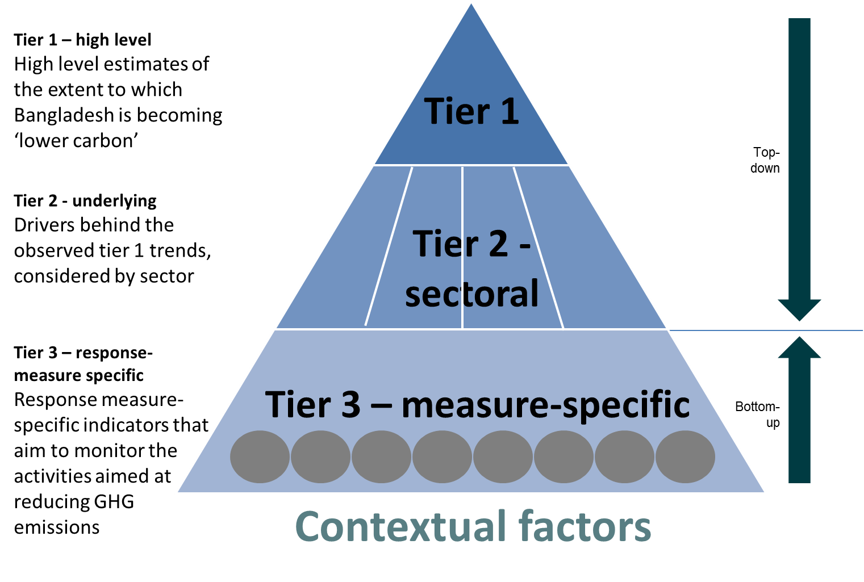

In many cases, the sectoral-level MRV will be directly connected to the national-level MRV, as the national-level data will simply be an amalgamation of data collected at the sectoral level. However there is more likely to be a disconnect between the national and sectoral levels on the one hand, and policy or project-specific reporting as shown in tier 3 in the diagram above. It is not expected that sectoral-level information will easily aggregate into sectoral-level information, but nonetheless the information collected at the tier 3 level will be important to provide context on the tier 1 and 2 data (e.g. explaining reasons for changes in GHG emissions levels) as well as providing important information on how effectively individual policies are performing, so that decisions on whether to continue with them in their present form can be taken.

Coordination by the DoE will be important to ensure that MRV in different sectors, and being carried out by different parties, is as consistent as possible, by encouraging use of common assumptions for key parameters, such as GDP, population, carbon intensity of the grid etc. The Bangladesh Bureau of Statistics would be expected to play a key role in this regard and will be encouraged to play a verification role on common assumptions that are being used for NDC-related MRV.

In the same way that the use of common assumptions will be important, to ensure consistency, there should also be, where possible and sensible, similar methodologies and approaches being used for calculating data for NDC MRV purposes. This could relate to a range of issues, including:

* Approaches to economic analysis (e.g. use of discounting for future costs).
* Approaches to assessing the scope of a measure, and the ‘boundary’ within which impacts are to be measured.
* Approaches to developing ‘business-as-usual’ estimate against which to measure progress ex-post.

As the MRV lead for NDC implementation, the DoE will work hard over the coming years to develop the national MRV system and to provide guidance on assumptions and methodologies to be used.

## NDC implementation activities: MRV

|  |  |  |  |
| --- | --- | --- | --- |
| *Activity* | *Responsibility* | *Timeline* | *Indicative cost / resource needs* |
| ***MRV*** | | | |
| *Agree MRV institutional arrangements for the MRV systems* | *DoE* | *September 2017* | *Minimal* |
| *Stocktaking of current monitoring and reporting processes, to consider what can be used for MRV of NDC implementation* | *DoE* | *September 2017 to April 2018* | *TBD – est. USD 100,000* |
| *Agree MRV institutional arrangements for the power, transport and industry sectors (see sectoral action plans for more detail)* | *DoE, working with SREDA, Road and Highways Division and Ministry of Industry* | *September 2017* | *Minimal* |
| *Agree final list of indicators for MRV of power, transport and industry sectors* | *DoE, working with SREDA, Road and Highways Division and Ministry of Industry* | *November 2017* | *Some staff time* |
| *Produce step-wise plan for GHG inventory improvement* | *DoE* | *October 2017 to May 2018* | *TBD – est.USD 80,000* |
| *Ongoing GHG inventory improvement* | *DoE* | *August 2017 to December 2018* | *TBD* |
| *Initial assessment of options for GHG projections for Bangladesh* | *DoE* | *Summer 2018* | *TBD – est. USD 200,000* |

Appendices

Appendix 1: summary of activities for implementing the NDC

Appendix 2: adaptation options for different sectors in Bangladesh

Appendix 1 - summary of activities for implementing the NDC

|  |  |  |  |
| --- | --- | --- | --- |
| *Activity* | *Responsibility* | *Timeline* | *Indicative cost / resource needs* |
| ***Governance*** | | | |
| *Draft detailed terms of reference for the NDC Implementation Advisory and Technical Committees* | *DoE* | *September 2017* | *Minimal* |
| *Write to proposed members of NDC Implementation Advisory and Technical Committees, inviting them to join* | *DoE* | *November 2017* | *Minimal* |
| *Draft detailed terms of reference for the NDC implementation analytical support* | *DoE* | *November 2017* | *Minimal* |
| *Arrange NDC Implementation stakeholder engagement workshop, to socialise the roadmap and NDC implementation more widely* | *DoE* | *Autumn 2017* | *Est 250,000 BDT* |
| ***Capacity building*** | | | |
| *Develop system of electronic data archiving for mitigation-related data* | *DoE* | *June 2018* | *?* |
| *Seek international support for comprehensive data review of mitigation data in power, industry and transport* | *MoEF* | *Autumn 2017* | *Minimal? Some staff time.* |
| *Draft terms of reference for comprehensive data review* | *DoE* | *October 2017* | *Minimal? Some staff time.* |
| *Launch tender for comprehensive data review* | *DoE* | *December 2017* | *Minimal? Some staff time.* |
| *Seek international support for capacity building on mitigation modelling* | *MoEF* | *Autumn 2017* | *Minimal? Some staff time.* |
| *Draft terms of reference for capacity building on mitigation modelling* | *DoE* | *October 2017* | *Minimal? Some staff time.* |
| *Launch tender for capacity building on mitigation modelling* | *DoE* | *December 2017* | *Minimal? Some staff time.* |
| *Consider options for international sharing of best practice on policy design* | *MoEF* | *June 2018* | *?* |
| *Write report on possible impact assessment approach for GoB* | *MoEF* | *December 2018* | *?* |
| ***NDC updating*** | | | |
| *Decision on priority sectors for consideration of inclusion in NDC* | *NDC Implementation Advisory Committee, coordinated by DoE* | *Summer 2018* | *Minimal* |
| *Assessment of abatement potential of selected sectors* |  | *November 2017 – December 2018* | *Est 20m BDT* |
| ***Finance*** | | | |
| *Set up institutional arrangements on climate finance* | *ERD, working with DoE* | *September 2017* |  |
| *Development of more accurate costings for mitigation measures* | *ERD* | *August 2017 to September 2018* | *Est 15m BDT* |
| *Detailed review of funding options* | *ERD* | *July 2017 to November 2017* |  |
| *Drafting of detailed Climate Investment Plan* | *ERD* | *October 2017 to July 2018* | *Est 20m BDT* |
| *Gap analysis of current finance tracking systems and institutions* | *ERD* | *August 2017 to November 2018* |  |
| *Develop central tracking system for climate finance, with standard methodologies* | *ERD* | *September 2017 to July 2018* |  |
| ***MRV*** | | | |
| *Agree MRV institutional arrangements for the MRV systems* | *DoE* | *September 2017* | *Minimal* |
| *Stocktaking of current monitoring and reporting processes, to consider what can be used for MRV of NDC implementation* | *DoE* | *September 2017 to April 2018* | *TBD – est. USD 100,000* |
| *Agree MRV institutional arrangements for the power, transport and industry sectors (see sectoral action plans for more detail)* | *DoE, working with SREDA, Road and Highways Division and Ministry of Industry* | *September 2017* | *Minimal* |
| *Agree final list of indicators for MRV of power, transport and industry sectors* | *DoE, working with SREDA, Road and Highways Division and Ministry of Industry* | *November 2017* | *Some staff time* |
| *Produce step-wise plan for GHG inventory improvement* | *DoE* | *October 2017 to May 2018* | *TBD – est.USD 80,000* |
| *Ongoing GHG inventory improvement* | *DoE* | *August 2017 to December 2018* | *TBD* |
| *Initial assessment of options for GHG projections for Bangladesh* | *DoE* | *Summer 2018* | *TBD – est. USD 200,000* |

Appendix 2 - adaptation options for different sectors in Bangladesh



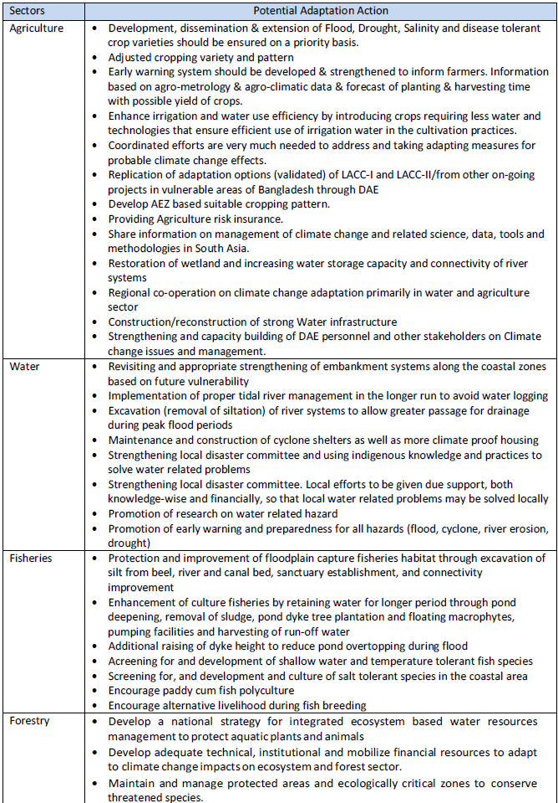

Source: extracted from SNC, 2012; DAE, 2015; BCAS, 2013

1. http://www.climatechangecell.org.bd/Documents/climate_change_strategy2009.pdf
2. http://www.lged.gov.bd/UploadedDocument/UnitPublication/1/322/11.%207th%20Five%20Year%20Plan(Final%20Draft).pdf
3. http://www4.unfccc.int/ndcregistry/Pages/Home.aspx
4. http://unfccc.int/resource/docs/publications/publication_ldc_napp_2013.pdf
5. https://sustainabledevelopment.un.org/?menu=1300
6. In total there are 14 sectors in the Seventh Five Year Plan but an action plan is not being developed for Defence.
7. https://www.ipcc.ch/report/ar5/
8. For more information, see <http://unfccc.int/adaptation/workstreams/national_adaptation_plans/items/6057.php>.
9. <http://unfccc.int/files/adaptation/cancun_adaptation_framework/application/pdf/naptechguidelines_eng_high__res.pdf>
10. https://www.ipcc.ch/pdf/assessment-report/ar5/syr/SYR_AR5_FINAL_full_wcover.pdf
11. The Representative Concentration Pathways (RCPs), describe four different 21st century pathways of GHG emissions and atmospheric concentrations, air pollutant emissions and land use.
12. Please note that natural disasters can be directly or indirectly caused by climate change and vulnerabilities pertaining to both need to be addressed through appropriate channels.
13. See pages 43-46 of the report prepared by the Government of Bangladesh on Cyclone Sidr – http://reliefweb.int/sites/reliefweb.int/files/resources/F2FDFF067EF49C8DC12574DC00455142-Full_Report.pdf
14. http://www.sciencedirect.com/science/article/pii/S0921818113002191
15. See page 61 of the Economics of Adaptation to Climate Change Synthesis Report at http://documents.worldbank.org/curated/en/646291468171244256/pdf/702670ESW0P10800EACCSynthesisReport.pdf’
16. Bangladesh GCF Readiness Proposal, October 2015. https://www.greenclimate.fund/documents/20182/466992/Readiness_proposal_-_Bangladesh.pdf/
17. http://www.greenclimate.fund/-/climate-resilient-infrastructure-mainstreaming-in-bangladesh
18. http://www.ndcpartnership.org/
19. http://www4.unfccc.int/sites/nama/SitePages/Home.aspx
20. http://www.mitigationmomentum.org/downloads/Financing_Supported_NAMAs.pdf
21. https://www.climatefinance-developmenteffectiveness.org/sites/default/files/documents/03_02_15/bangladesh%20cpeir%20summary%20formatted.pdf
22. See here for more details - <http://cdkn.org/wp-content/uploads/2016/06/Business-case-for-the-Bangladeshi-private-sector-to-invest-in-climate-change-and-access-international-climate-finance.pdf>
23. <http://cdkn.org/wp-content/uploads/2016/06/Private-sector-engagement-in-climate-change-action-in-Bangladesh-creating-an-enabling-environment.pdf>
24. http://www.cdkn.org/ndc-guide/book/planning-for-ndc-implementation-a-quick-start-guide/measuring-reporting-and-verification/
25. Articles 13(7), 13(8) and 13(10) of the Paris Agreement.